Burnham-on-Sea-Harriers
Present
Burnham-on-Sea Half Marathon
Sunday 6th October 2019
11:00 am
Under UKA Rules
Course Measurement Certificate: SEAA 16/211
Race Licence: 2019:36722
Supported by:
Burnham-on-Sea Lions Club
St John’s Ambulance
Burnham Association of Sports Clubs
Brean Leisure Park
1st Huntspill & Highbridge Scout Group

Welcome to Burnham-on-Sea
Thank you for entering the Burnham-on-Sea half marathon. I hope you enjoy the race and have a good day in Burnham-on-Sea.
Please take a few minutes to read this race pack so you know what to do on race day.
Good Luck!
Stuart Anderson – Race Secretary
Email: BurnhamHarriers@gmail.com
Thank you to all the marshals and volunteers for their invaluable assistance and support in ensuring this event runs smoothly.
Race Information
Race HQ: BASC sports-ground, Stoddens Road, Burnham-on-Sea, TA8 2DX
Due to this venue being a Sports ground, BASC operate a NO-dogs on site policy
Directions: From the M5, exit junction 22. At the Edithmead roundabout take the 2nd exit heading towards Burnham on Sea. At the Tesco roundabout, take the third exit into Stoddens Road and follow this road for approximately ¾ mile. BASC is on your right.
Parking: There is ample parking at BASC sports-ground, but please obey the directions provided by the parking marshals
Toilets: Available in the clubhouse
Changing: Changing facilities are available in the clubhouse. Please use the changing facilities marked for runners and do not change in the bar.
Refreshments: The clubhouse has a licensed bar and refreshments
Start: The race will start at 11:00am. A runner’s brief will be given prior to the start. The start and finish line is on the grass adjacent to the rugby pitch. The course involves a circuit of the cricket pitch at the start and finish.
After the start, the access road will be closed until the last runner leaves the sports-ground and enters the road section of the course.
Race Numbers: Please ensure your number is secure to the front of your vest and is visible throughout the race. Do not cut or fold the number.
Race numbers will not be posted but will be available for collection on the day in the clubhouse.
UKA Rules 240s Prohibits the use of headphones for this race. Bone Conductors can be used.
Time limit: There is a time limit of 2hours 30minutes for this race, at which point the marshals will withdraw from their posts. Anyone left on the course will become pedestrians and expected to navigate their way back to the finish
Course: The course map is on the entry form and Burnham-on-Sea Harriers website: http://www.burnham-on-sea-harriers.com/burnham%20half.html
Once you have left the BASC sports-ground the course follows open roads. Please take care, keeping aware of other road users and keep to the left-hand side of the road at all times as vehicles and pedestrians will also be on the course.
Marshals will be present throughout the course and direction arrows are marked at every junction. Mile markers are displayed along the course. A lead car will display the race clock from which commentary will be relayed to race HQ. Extra marshals will be posted at mile 4 where runners have to cross traffic. Please take care here.
There are to be no accompanying dogs, bikes or vehicles as this can cause additional hazards to fellow runners and other road users.
Course Records
Male: 2009 – Adrian Harris – Wells City Harriers – 1:08:57
Female: 2005 – Karen Hazlett – Winchester & District AC – 1:19:57
Drinks: There are 3 water stations along the course. Water and refreshments also available at the finish.
First Aid: St John Ambulance will provide first aid cover along the course and at Race HQ. If you need to pull out during the race please alert a marshal and we will do our best to return you to Race HQ.
Results: Provisional results will be available on the day. Results will be posted on Burnham-on-Sea.com and Burnham-on-Sea-Harriers.com.
Prize giving: The presentation will take place in the clubhouse at approximately 2:00pm
Categories:
Male Overall – 1st, 2nd & 3rd Female Overall – 1st, 2nd & 3rd
Male Age Group Winners: Female Age Group Winners:
17-19 years 17-24 years
20-29 years 25-34 years
30-39 years 35-44 years
40-49 years 45-54 years
50-59 years 55-64 years
60-69 years 65+ years
70+ years
Local Male 1st, 2nd & 3rd Local Female 1st, 2nd & 3rd
1st Local Male Vet over 40 1st Local Female over 35
One prize per competitor (Except local prizes)
Local is Burnham Harrier or unattached runner with TA8 or TA9 postcode
Medical Advice
If you have any medical problems that make it a risk for you to run, please inform the organisers before you take part. You should also inform your GP that you are running in a half marathon and seek appropriate medical advice.
If you have a medical condition that may require special attention during the race, please state this clearly on the back of your race number.
Please write the name and emergency contact number on the back of your race number before you start your race.
Make sure your friends and family know your race number and estimated finishing time.
If you feel unwell or have any doubts about running on the day do not run. There are plenty of other races you can enter.
Drink plenty of fluids before, during and after the race. Take plenty of sips and remain hydrated.
FUN RUN
A 1-mile fun will also take place around the BASC sports-ground and will start at around 11:30am. The fun run will use the same start and finish as the half marathon. Entry for the fun run to be made on the day and is open to all ages. The fun run is limited to 100 competitors.
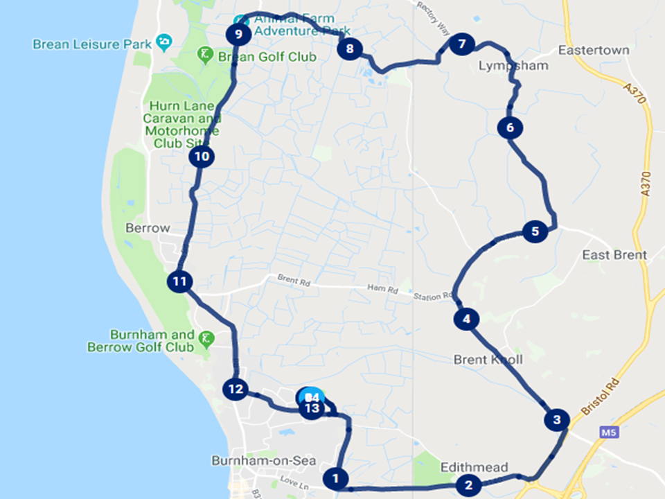
Entry fee for the fun run is £2 with all proceeds going to Burnham and District Lions Club. All finishers will receive a medal.
Half marathon course:
Starting at the BASC Sports ground, runners take a short loop of the ground before exiting and turning left onto Stoddens Road. At the Tesco roundabout, turn left onto Queens Drive. A left turn is taken at Edithmead roundabout and then another left into Brent Knoll. Running with the Knoll on your right hand side, take a left into West Road entering Lympsham. A further left is taken onto Wick Road and then to Red Road until you reach Berrow. A run along the Berrow Road, back into Stoddens Road, entering the BASC Sports ground for the final loop to the finish.
